DRAFT VERSION

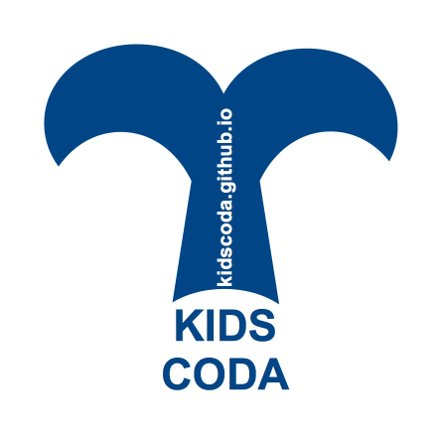

THE PROJECT



kidscoda.github.io

made with by
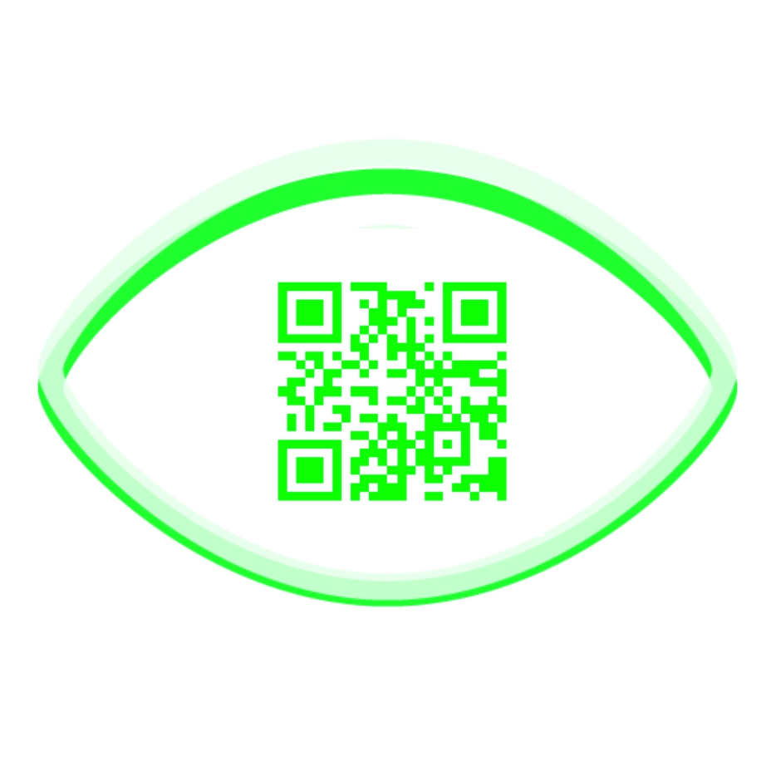
www.360.unipr.it

TRESEIZER0
Virtual lab for Digital Social Innovation for Learning
Department of Medicine and Surgery
University of Parma

in collaboration with
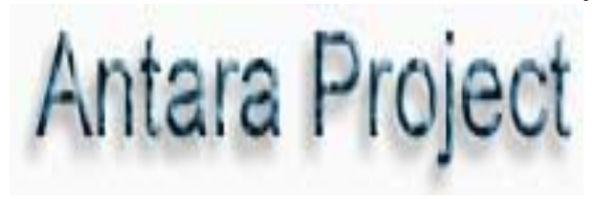
www.antara-project.com

This work is distributed under a
Creative Commons Licence 4.0



KIDSCODA

What it is?
An experimental transdisciplinary project for children (ages 4 and up) and teens...so kids! about making, bioacoustics, marine biology, communication and coding. For non-English speakers it is also an opportunity to learn English.

So KIDSCODA can be considered a STEAM project (Science, Technology, Engineering, Arts and Math).

Why did we create this project?
The approach is practical, innovative and intuitive.
Water as H2O, the seas and the oceans constitute an element and an environment used seldom in pedagogical and scholastic contexts, even though they are fundamental resources for life and metaphors of life, about its origins and evolution. Based on the most recent research on the behaviour of marine mammals (in particular on sperm whale groups), examples are used to make people understand how underwater communication occurs between intelligent beings (the sperm whales' brain mass is equal to 6 times of that of humans). By using do-it-yourself hydrophones it is possible to experience how underwater sounds are produced and perceived.
This brief experience constitutes an approach to simulation and to creative and relational involvement as a form of learning.
A submerged and fascinating world that brings to the attention of the participants also respect for the environment and the need for its preservation.

How is it organized?

The project is organized in 4 interdisciplinary modules:

[] CODA SPERMWHALES SPEAK

[] SOUNDS PLAY IN THE WATER

[] SIMULATION BEHAVE LIKE SPERMWHALES
[] CODING SHARE YOUR CODE


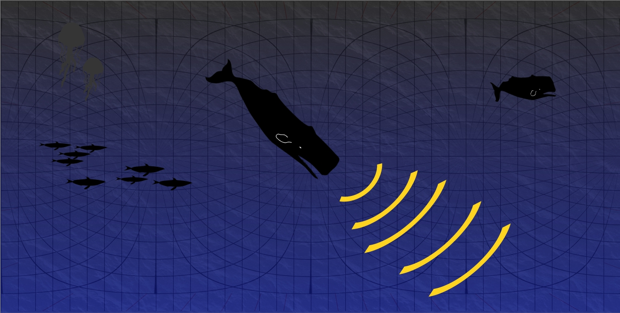

What do you need to have?

[] volunteers or collaborators (the ratio should be one for each 5/6 participants) or run sessions for 5/6 participants for a more or less wide audience

[] a facilitator who practices Scratch and trains himself with the material published on the site

[] piezoelectric pickups in needed quantity (*)

[] audio cables with ¼ jack

[] audio mixer with ¼ inputs

[] audio system (> 50 W)

[] Projector, LIM or large video screen with HDMI or VGA input

[] wifi network accessible with a sufficiently powerful signal

[] for coding: a sufficient number of computers (one for every 5/6 participants) ... possibly no windows environment!!!

[] bowls and / or containers for the sufficient number of participants

[] pieces of terracotta or porous material (corals, lava, pumice stone, etc ...)

[] straws

[] wooden sticks (chopsticks)

(*) meant for the DIY hydrophones

PHASES:

CODA
SPERMWHALES SPEAK

In the first phase is presented in a elementary and popular form the state of research on cetacean communication, in particular sperm whales, based on their evolutionary, physical, social and functional characteristics with respect to the water environment.

SOUNDS
PLAY IN THE WATER

In the second phase the do-it-yourself hydrophone will be presented; given peculiar conditions it is possible to construct hydrophones together (DIWO - Do It With Others). The hydrophones will be connected to a mixing desk and an amplification system. Films related to listening to underwater sounds will be presented with professional and self-made hydrophones.

SIMULATION

ACT LIKE SPERMWHALES

Then the participants will be able to experience the production and listening of sounds under water in bowls and various containers to produce different sounds and effects. By first dipping the fingers to move the water and gradually producing various sounds, they will be able to hear the air coming out of porous and terracotta pebbles in immersion and with bubbles making bubbles. Even beating the vessels with sounds with wooden sticks. More children together will create underwater symphonies and explore how sound manifests beneath the surface of the water contained in containers of different sizes and materials.

CODING

SHARE YOUR CODE

Eventually, PCs will be used to familiarize with the block code of the scratch.mit.edu platform and / or microbit programming; this will make possible to understand the importance of the code and how it favors the transmission of more or less complex information among peers.

Enjoy!

GOAL OF SIMULATION

The aim of the project is to bring citizens, students and teachers together with simulation methods of scientific dissemination, tinkering and DIWO (Do It With Others). Therefore, examples and metaphors are used to explain emerging forms of communication, bioacoustics and animal intelligence currently at the center of the debate scientific. Not least the preservation of the environment and of animal species at risk.
The resources are mainly in English, giving the opportunity to non-English speakers to approach the foreign language.

We will proceed intuitively and leave room for considerations and reflections. The various points touched in the transdisciplinary path starting from how communication under water occurs in physical terms (the sound propagates at 5 km instead of 600 m per second as the water it is denser than the atmosphere) and the fascinating life of sperm whales. Bioacoustics will be presented based on the anatomy of the sperm whales and the communication between individuals in a collective context will be simulated by listening to codes shared in groups of individuals using metaphors and examples from the world of cetaceans in the most basic way.
The materials and digital resources of the courses are made available to the facilitator by consulting the kidscoda.github.io website which can be accessed in a git environment for changes and sharing based on the CreativeCons license.

For parents, citizens, trainers and professors who are interested in improving the project and studying topics such as shared simulation practices, communication between cetaceans and coding with and for new generations, it is possible to continue and develop KIDSCODA by arranging free meetings organised by 360, (www.360.unipr.it) the Laboratory for Digital and Social Innovation for Learning of the University of Parma, Department of Medicine and Surgery at Pavilion 27 within the hospital perimeter of the Maggiore Hospital of Parma, Italy.

NOTES
........................................................
........................................................
........................................................
........................................................
........................................................
........................................................
........................................................
........................................................

